1. 
2. 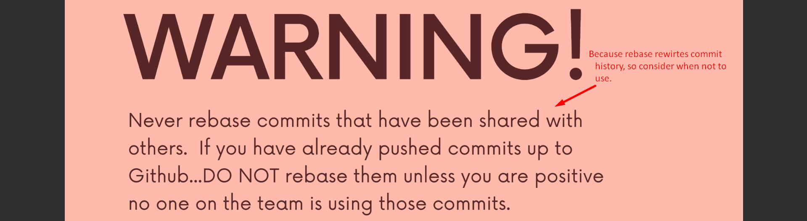
3. 
4. Never rebase if you have shared your commits with someone else somehow.   
   Although there are ways to fix it but not a fun.
5. If working with a company, then very clear instructions about the workflow like
   1. We can use rebase.
   2. When to use rebase.
   3. When not to use rebase.
   4. Use rebase in X Situation and merge in Y Situation.